Name: Devang. A Dedhia Department: CYSE
Div: BE-15 Roll No: 66
Sub: Mobile Forensic Lab

Experiment No: 2
Date of Performance: | 30/01/2025
Date of Submission: | 06/02/2025
Program formation/ Execution/ ethical practices (06) | Timely Submission (01) | Viva Answer (03) | Experiment Marks  (10) | Teacher Signature with date

Experiment No. 2

Aim: Data Acquisition via custom RAMDisk / JailBreak / iOS Backups.

Lab outcome: Demonstrate tools and techniques used for data acquisition, analysis and recovery of data from iOS mobile devices.

Theory:
Data acquisition from iOS mobile devices involves employing specialized tools and techniques to extract, analyze, and recover information for forensic purposes. The aim of this experiment is to showcase the utilization of custom RAMDisk creation, jailbreaking, and iOS backups as methods for data acquisition. Each technique addresses distinct aspects of iOS devices, allowing forensic analysts to navigate security measures and retrieve valuable data.

- Custom RAMDisk Creation: The creation of a custom RAMDisk involves establishing a temporary storage space in the device's memory. This method allows for the extraction of volatile data, providing insights into live system activities, running processes, and other real- time information. This is particularly valuable for capturing data that may not be accessible through conventional means.

- Jailbreaking: Jailbreaking is the process of removing software restrictions imposed by Apple on iOS devices. By bypassing these restrictions, forensic analysts gain access to restricted areas of the file system, enabling the extraction of a broader range of data. Jailbreaking is a powerful technique for acquiring information beyond what is typically available through official channels.

- iOS Backups: Creating backups of iOS devices is a standard practice in mobile forensics. Backups capture a snapshot of the device's data, including user settings, applications, and content. This method is less intrusive than jailbreaking and provides a comprehensive dataset for analysis. iTunes or Finder on macOS are commonly used tools to initiate and manage iOS backups.

Output:

Creating an iOS Backup:
- Connect iOS Device: Use a USB cable to connect the iOS device to a computer with iTunes. If prompted, authorize the connection on the iOS device.
- Launch iTunes: Open iTunes on Windows.
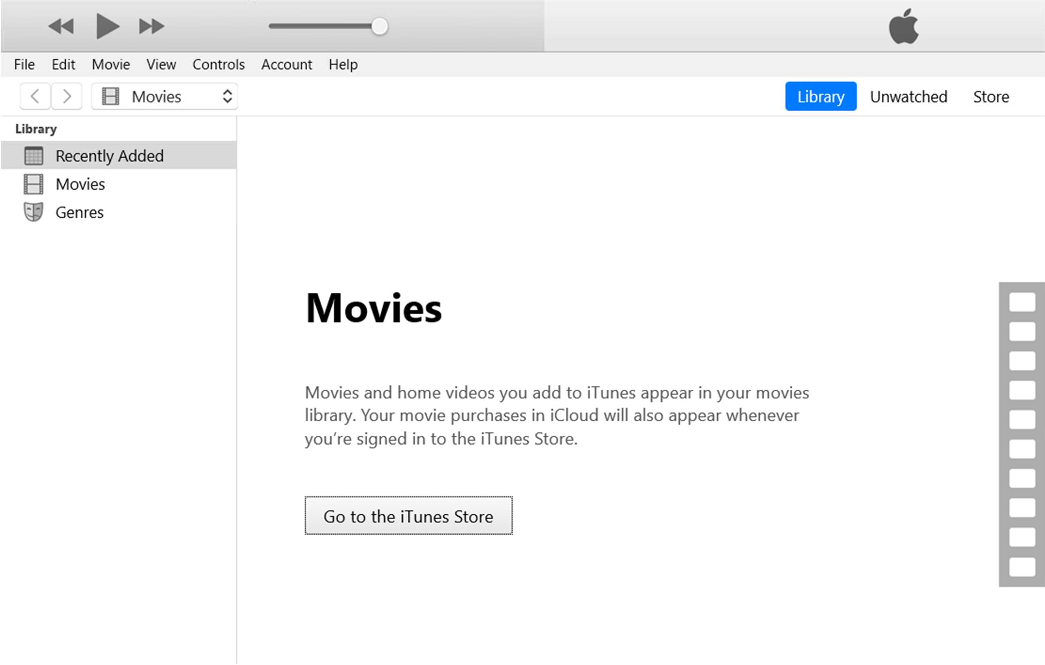

- Select the device which you want to back up. The device will be shown in the Devices section.
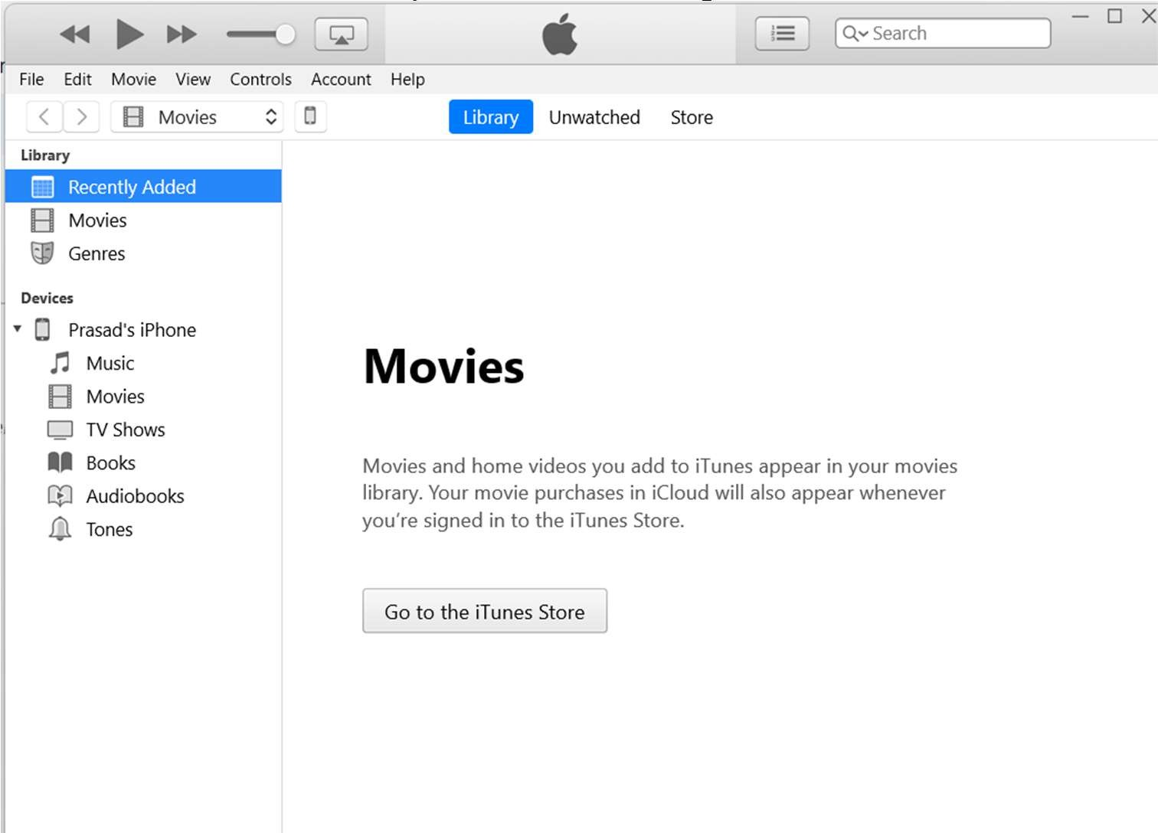

- Initiate Backup: Click on the "Backup Now" button to start the backup process.
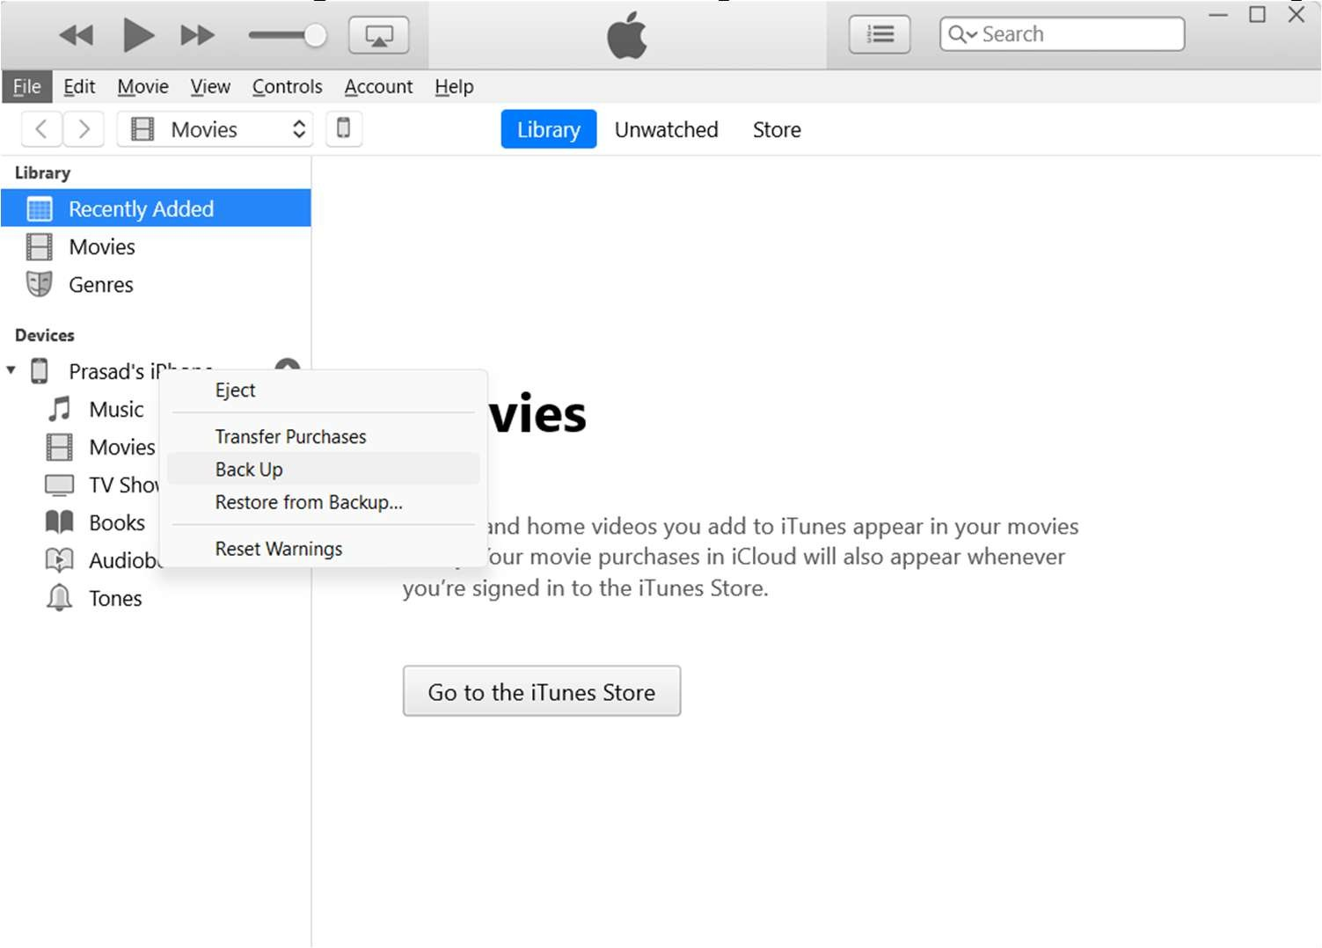
- The backup will be stored in the default location[C:/Users/Username(user account)/Apple] or as it is configured in the iTunes application.
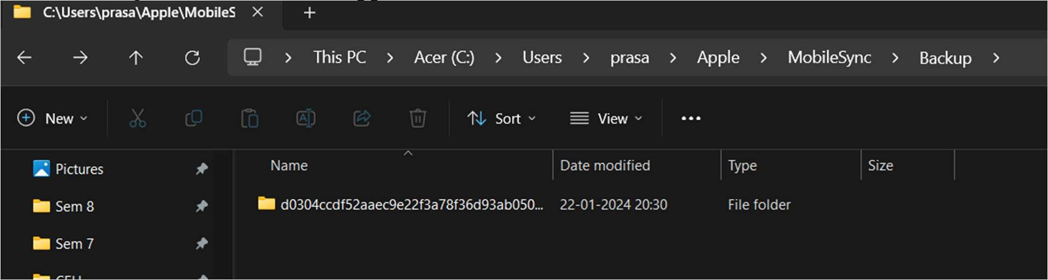

- The output is a comprehensive backup file containing the iOS device's data, stored in the designated backup folder on the computer. This file serves as a crucial dataset for subsequent forensic analysis.
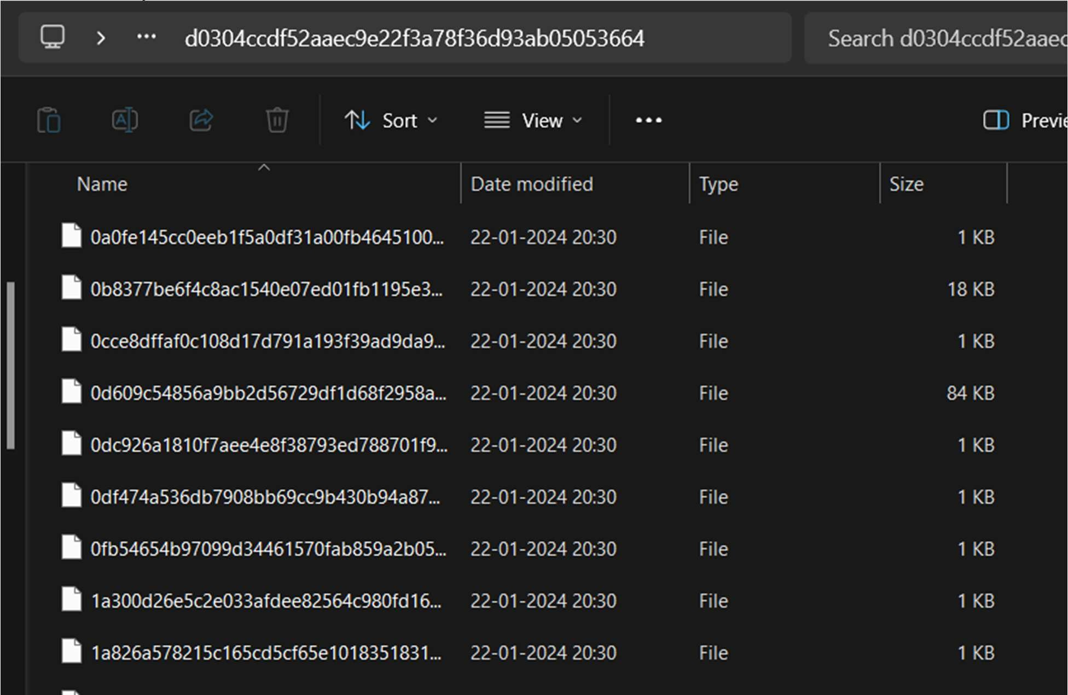

Conclusion:
In this experiment demonstrated the tools and techniques employed for data acquisition, analysis, and recovery from iOS mobile devices.

